OGDEN’S ENCYCLOPEDIA OF RADIO HORROR—“Q” Copyright © 2010 Vanished Voices OTR
`

Q 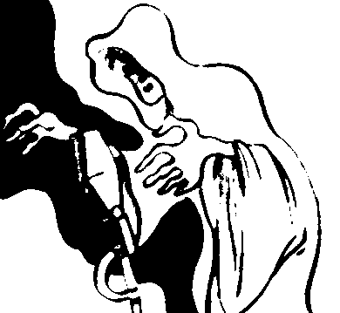

Q
[RADIO-PLAY]

(3AR, MELBOURNE)
[Tuesday—7:56-8:22 PM]
July 26, 1927 “Q”
[ADELAIDE ADVERTISER: “…Radio play, entitled ‘Q’ (Stephen Leacock). A psychic of the super-natural…”]

THE QUEEN OF SPADES
[SHORT-STORY]

WE KNOW A STORY (WONS, HARTFORD)
[???day—10:00-10:15 PM]
August 1, 1948 “The Queen of Spades”
[RADIOGOLDINDEX: “…The program was recorded July 27, 1945????…”]
CAST: Joan Burke, Guy Hedlund.
EXTANT RECORDING

